Carbon Footprint-based Approach to Minimize Building Environmental Impact in Egypt

(البصمة الكربونية كمدخل لتقليل الأثر البيئي للمباني في مصر)

Riham Hagag(1), Sherif Sheta(2), Medhat Samra(3)

*(1) Riham Hagag: Teaching Assistant at the Faculty of Engineering, Benha University.*

*(2) Sherif Sheta: Associate Professor at the Faculty of Engineering, Mansoura University.*

|  |
| --- |
| ***الملخص العربي:-*بشكل عام تساهم المباني بأكثر من 30٪ من إجمالي انبعاثات غازات الاحتباس الحراري العالمية. وفقا لبرنامج الأمم المتحدة للبيئةUNEP, 2011 ، من شأن تخفيضات الغازات الدفيئة GHGأن تقدم مساهمة كبيرة من ضمن الجهود المبذولة للحد من ظاهرة الاحتباس الحراري. وفقا للهيئة الحكومية الدولية المعنية بتغير المناخ (IPCC)، هناك ثلاثة مجالات للتركيز عند الحد من انبعاثات ثاني أكسيد الكربون(CO2) من المباني: تقليل استهلاك الطاقة في مرحلة الاستخدام، والاتجاه إلى الطاقة المتجددة في التصميم، واستخدام مواد مستدامه في البناء. يهدف هذا البحث الوصول للمجتمعات ذات الكربون المقترب للصفر بدراسه وتحليل بعض المباني العامه والتركيز على قطاع المباني السكنيه حيث انها تمثل اكبر نسبه كثافه مابين باقى القطاعات داخل المدينة. وبالنهايه الخروج بتوصيات لتقليل الأثر البيئي السالب للمباني وبالتالي تقليل استهلاك الطاقه والبصمة الكربونيه سواء أثناء مرحلة التصميم وإعداد الدراسات اللازمة للمبنى (باستخدام الطاقات المتجددة) أو أثناء مرحلة الانشاء (باستخدام مواد البناء صديقة البيئة) أو خلال فتره الاستخدام (بتطبيق التقنيات المتوافقة بيئيا في صيانة وتشغيل المبنى القائم).**  **KEYWORDS:**  ***Carbon footprint, CO2 emissions, zero carbon buildings, Environmental Impact, Green materials, Energy consumption*** |

*(3) Medhat Samra: Lecturer at the Faculty of Engineering, Mansoura University.*

*Abstract*— buildings contribute more than 30% to total global GHG emissions. In efforts to reduce global warming, GHG reductions would make a significant contribution (UNEP, 2011). According to the Intergovernmental Panel on Climate Change (IPCC), there are three areas to focus when reducing CO2 emissions from buildings: switching to renewable energy in designing, using green materials in construction, and reducing energy consumption in building operation. This paper aims to investigate world experience in achieving zero carbon community by analyzing and comparing some international and national examples of public buildings and especially focusing on housing sector as it represents the largest proportion among the rest of the building sectors within the city. This paper finally recommends how to mitigate the buildings' environmental negative impact, therefore reducing the energy consumption and the building's carbon footprint whether before construction-stage (by adopting renewable energies), during construction (by integrating environmentally friendly construction materials) or during the use-stage (by applying appropriate techniques in building operation and maintenance).

# **1. Introduction**

According to IPCCC 2011, CO2 emissions in Egypt was increased from 220 MtCO2e* in 2005 to 275 MtCO2e in 2010, and are expected to double by 2030 reaching 550 MtCO2e [1]. It seems to cause an extensive risk, so it is necessary to search for mitigation methods of the building carbon footprint. Since most of the city buildings belong to the residential sector, this paper tackles a larger number of housing examples to formulate a set of building carbon mitigation criteria that should govern a zero carbon community.

In order to achieve the research stipulated aim, the study traces the following comparative analysis for five selected international and national building examples from both public and residential sector.

# **2. Previous studies**

2.1. The Engineering Pavilion at Curtin University in Australia (Building 216)

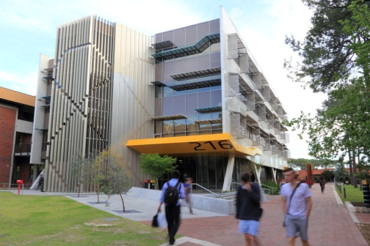

*Figure (1): Australian Engineering Pavilion (Building 216)*

Location: Curtin University in Perth, Western Australia, Year: has finished in 2012, Area :3000 m2

*\**million tons of CO2 equivalent, the common unit for measuring all greenhouse gas emissions in terms of CO2

Building 216 Includes flexibility and natural light. It holds flexible academic offices and teaching accommodations and Consists of 4 levels. This project has been awarded a 5 Star "Green Star" – Education Design v1 certified rating from the Green Building Council of Australia which represents Australian Excellence in environmentally sustainable design [2].

Although the University utilizes a Building Management System (BMS) which reduces the building's usage stage produces 63% less GHG emissions and the total embodied energy consumption 20% less than the University average [3], It has a big carbon footprint due to construction and use stage. Wahidul K. (2014) Followed ISO14040–44 guidelines using Simapro 7.2 software to calculate The life cycle GHG emissions of the Building from the construction and usage stages which were 14,229 ton CO2e and the embodied energy of the building 172 TJ.

Because of the high energy intensities involved in the manufacture of concrete and aluminum, Wahidul K. (2014) suggested to use cleaner production strategies to improve the energy performance of the building's construction materials and reduce the (Building 216)'s carbon footprint by the following strategies:

1. The replacement of 30% by weight of cement (used in the building) with fly ash in concrete formulations would avoid nearly 47% of the total GHG emissions in the mining to material production stage (i.e., 6,687 tonCO2e).
2. The substitution of new aluminum with recycled aluminum reduces GHG emissions by around 70% (i.e., 9,96 tonCO2e).
3. The substitution of new steel with recycled steel will reduce GHG emissions by around 60% (i.e., 8,537 ton CO2e).

*Learned lessons:*

The substitution of some of the traditional commercial building's material either in material production or in construction stage caused a potential saving in carbon footprint at minimum 50: 60% by reducing the total embodied GHG emissions (which mainly involve CH4, CO, CO2).

2.2. A Residential Building "Retrofitting Suggestion" (Egypt)

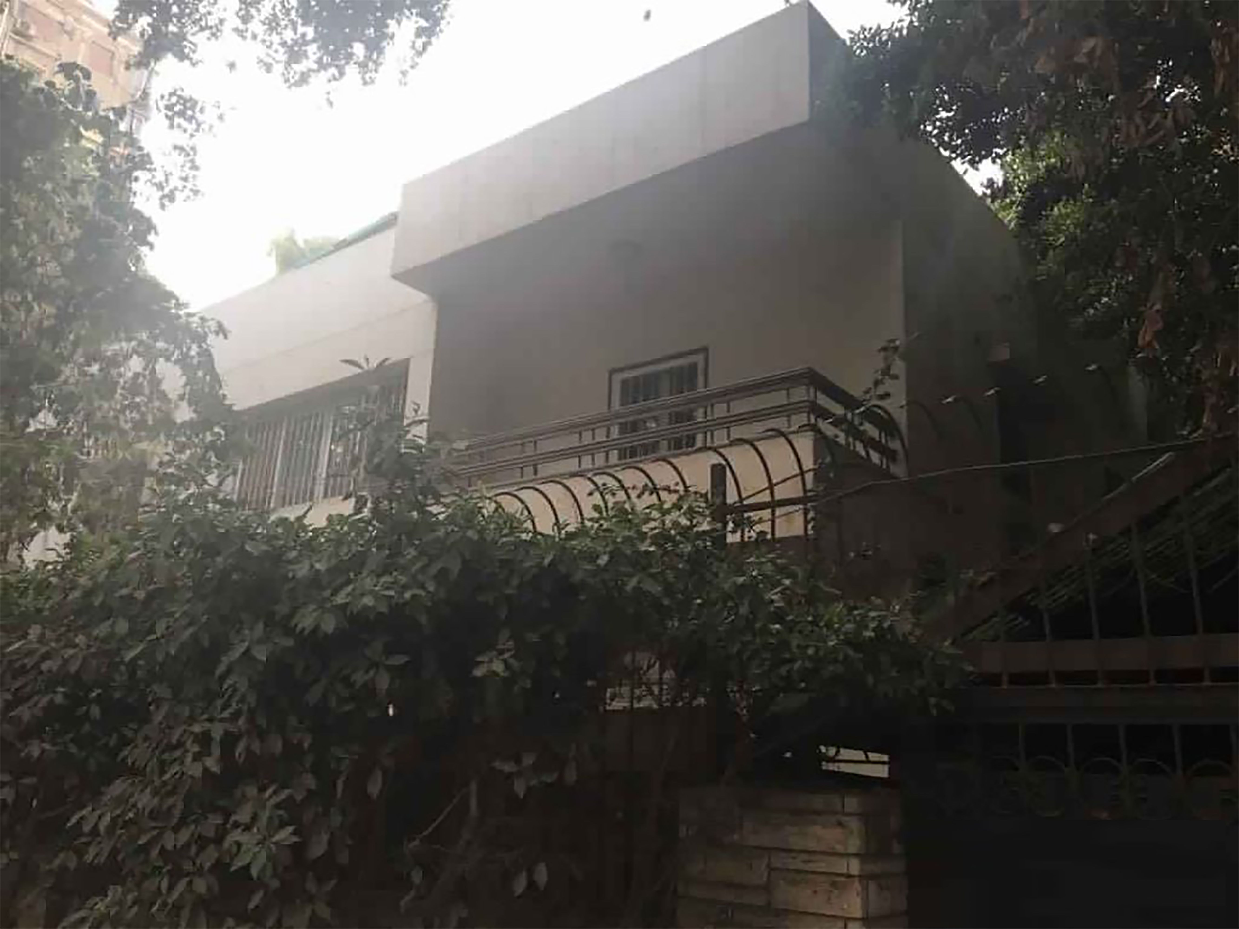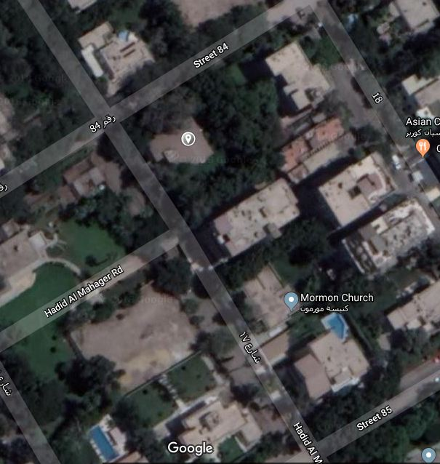

*Figure (3, 4): Random residential building and location from google earth, El maadi*

Location: Embassies district, El Maadi– Cairo

Mohamed G. (2015) has assessed the performance of a simple random villa with total floor area of 70 m2, located in Embassies district-El Maadi, by analyzing the energy consumption and carbon dioxide emissions outputs, using simulation tools design-builder program in steps [5]:

1. Simulation as an existing building design and building construction.
2. Suggestion of adding insulation material and improving thermal bridging and air tightness.
3. Simulation after villa retrofitting and analyzing how this refurbishment does a reduction in carbon dioxide emissions outputs.

*Mohamed G. (2015) Suggested adding insulation material to:*

* The external wall construction: consists of three layers 250 mm hollow red brick, 13 mm inner Egyptian plaster and 15 mm outer plaster layer that achieve U-value 1.456 (W/m2K). Adding external insulation achieved 0.3 (W/m2K).

|  |  |
| --- | --- |
| D:\master\Capture.JPG | *Figure (5): show the external wall layer*  *Source: (Mohamed G, 2015)* |

* The floor construction: The ground floor was having solid concert floor without insulation or special treatments and has greatest heat loss. It consists of 4 layers that can achieve U-value 1.87 (W/m2K). Adding 100 mm of mineral wall insulation can achieve U-value of 0.24 (W/m2K).

|  |  |
| --- | --- |
| D:\master\Capture.JPG | *Figure (6): show new construction of floor*  *Source: (Mohamed G, 2015)* |

* The roof construction: The dwelling was having flat roof the U-value of the roof was 0.954 (W/m2K). It is insulated with 100 mineral wall that can achieve U-value 0.29 (W/m2K).

|  |  |
| --- | --- |
| D:\master\Capture.JPG | *Figure (7): show new roof insulation*  *Source: (Mohamed G, 2015)* |

* windows and doors: Most of glazing in house is single-glazed with timber frame. The windows were believed to have air-filled gap between the layers, so it has U-value 6.25 (W/m2K). Using triple glazing with 6 mm air gap, higher solar transmitting properties and increasing the glazed area that increased levels of natural light reduce energy demand for lighting. and achieves 1.00 (W/m2K) [5].

All these added insulation materials reduced energy consumption and the total carbon footprint for the dwelling was reduced around 7.5 %.

*Learned lessons:*

Adding insulation materials to the building elements reduce the energy consumption and so reduce the total CO2 emissions as it could achieve a large reduction of the U-value as the following:

1. Using insulation material in the wall construction could achieve a reduction of U-value more than 79%.
2. Using insulation material in the floor construction could achieve a reduction of U-value more than 87%.
3. Using insulation material in the roof construction could achieve a reduction of U-value more than 69%.
4. Using insulation material in the windows and the doors construction could achieve a reduction of U-value nearly 84%.

And so the energy consumption and the carbon footprint would reduce around 7.5% [5].

# **The case studies of CO2 mitigation**

# **3.1. The selection criteria of case studies**

The five selected examples are based on their different treatment methods of CO2 emissions: some of these examples used innovative (active and passive) design methods from the beginning of the design-stage; while other examples used sustainable materials through the construction-stage, also other examples have been added advanced elements of technology in the use-stage, and there are also examples which was a zero carbon building from the beginning.

# **3.2. Public buildings**

* + 1. The American University in Cairo (AUC), New Cairo, Egypt

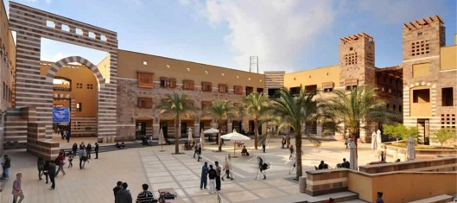

*Figure (8): The American University in Cairo, New Cairo*

Location: New Cairo, Egypt

Founded: in 1919

Area: 260 acres [6]

**3.2.1.1. Building description:**

* AUC aspires to enhance sustainable development in all its activities.
* Since September 2008, the University moved the bulk of its operations from 9 acres of campuses centered on Tahrir Square in downtown Cairo to an all-new state-of-the-art 260 acres campus in the developing desert city of New Cairo. Therefore, the budget of the University’s operation has been more than doubled, and the student, faculty, and staff head counts have been increased and University’s activities have expanded. Thus, it's carbon footprint has a significant increase by the Academic Year 2012 (AY 12) (September 1, 2011 through August 31, 2012).

**3.2.1.2. Carbon footprint before retrofitting:**

At (AY 12), Jaskolski T et al. proved through a studied analysis that the AUC's carbon footprint was calculated to be 37,712 MT CO2e [6] and there are six main contributors

(1) HVAC and domestic hot water (20,296.4 MT CO2e).

(2) Lighting and other electrical equipment (8,888 MT CO2e).

(3) Paper consumption (689.1 MT CO2e).

(4) Water supply (720.3 MT CO2e).

(5) Transportation (especially commuting by bus and car) (8,290.5 MT CO2e).

(6) Use of refrigerants (566.2 MT CO2e) [7].

**3.2.1.3. Retrofitting elements:**

AUC controlled the six main contributors to the carbon footprint which were divided to reductions and increases for each major category of emissions between AY 12 and AY 14 as the following:

Fist: Healthy reductions in carbon emissions from:

1. HVAC and domestic hot water (-22%)
2. Lighting and other electrical equipment (-8%).
3. Paper consumption (-21%).
4. Water supply (-25%).

Second: That four reducing elements were offset to a significant extent by increases in emissions from:

1. Transportation (especially commuting by bus and car (+25%).
2. Use of refrigerants (+13%).

**3.2.1.4. Carbon footprint after retrofitting:**

*Table (1): The reductions and increases of Carbon footprint resulted after retrofitting* [6].

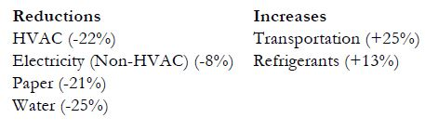

Only after two years; between (AY 12) and (AY 14), AUC’s carbon footprint decreased by nearly 1,611 MT CO2e (from 37,712 MT CO2e to 36,102.39 MT CO2e) or by approximately 4.25% of the total carbon footprint of (AY 12).

The six main contributors to the carbon footprint reduction after retrofitting became at (AY 14):

1. HVAC and domestic hot water 43.6% (15,831.2 MT CO2e).
2. Lighting and other electrical equipment 22.5% (8,177 MT CO2e).
3. Paper consumption 1.5% (544.4 MT CO2e).
4. Water supply 1.5% (540.2 MT CO2e).
5. Transportation (especially commuting by bus and car) 28.6% (10,363.1 MT CO2e).
6. Use of refrigerants 1.8% (639.8 MT CO2e).

**3.2.1.5. Learned lessons:**

From the analysis of "AUC" we found that: the most important factors of the building's Carbon Footprint (which reduction fit proportionally with the reduction of the Carbon footprint) are:

1. HVAC (Heating, ventilation, and air conditioning) and domestic hot water.
2. Artificial lighting and other electrical equipment.
3. Paper consumption.
4. Water supply.
   * 1. Pusat Tenaga Malaysia’s Zero Energy Office (PTM's ZEO)

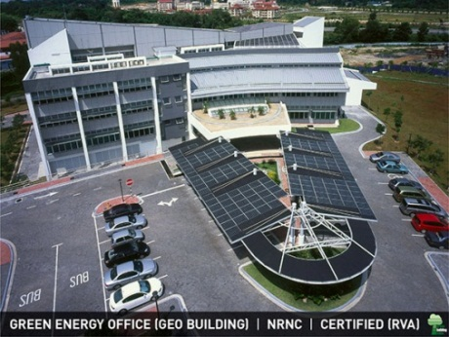

*Figure (9): The Malaysian zero carbon office, Pusat Tenaga*

Location: Section 9, Bandar Baru Bangi, Bangi, Selangor

Year: finished in July 2007

Site Area :2 hectares [8].

**3.2.2.1. Building description:**

* ASEAN Energy Award (EA): 2009, 2010, 2011
* 65 TCO2/year
* Green Building index (GBI): Certified (2009)
* Net Building Energy Index (Net BEI): 30 (86% reduce)
* The PTM’s ZEO was the first completely self-sustainable building in Southeast Asia, operates on the dynamics of both passive and active techniques and onsite renewable energy generation (the solar BIPV system).
* PTM’s ZEO building does not use fossil fuels. Instead of that, all electricity needed by the building is being generated by its own solar BIPV systems.

**3.2.2.2. Carbon footprint before retrofitting:**

The four solar systems (BIPV) have been installed into PTM’s ZEO as the following distribution:

* The first and the biggest component features the 47.28 kWp polycrystalline BIPV system on the main roof.
* The second component lies with the 6.08 kWp amorphous silicon BIPV system incorporated in the second roof.
* the third component stored in the atrium of the building highlights the use of the11.64 kWp monocrystalline glass-glass BIPV system.
* The last component in the car park roof is fitted with 27 kWp monocrystalline BIPV system.

The total BIPV capacity is 92 kWp [8].

**3.2.2.3. Retrofitting elements:**

Energy efficient is being achieved by:

1. Solar BIPV systems which linked up to grid-connected inverters which convert the produced direct current (DC) electricity into alternating current (AC) electricity and for verifying the electricity production, electricity generation is recorded through the meter before using. In this case, no battery is installed because the generated solar electricity is directly consumed and the net surplus is being sold to Tenaga Nasional Berhad (TNB).
2. PTM's achieves the super energy consumption by incorporating features utilizing passive techniques (orientation and vegetation) as well as active features (efficient lighting systems, floor slab cooling, double-glazed windows and a thermal wall at its east- and west-facing façades).

**3.2.2.4. Carbon footprint after retrofitting:**

Benefits of using these two systems:

the total BIPV used capacity is 92 kWp (47.28 + 6.08 + 11.64 + 27). To date, the BIPV systems have produced about 103 MWh/year average. Buildings that are not energy efficient would need more than 92 kWp as compared to PTM’s ZEO. This is because the super energy efficient (EE) features of ZEO which reduces the energy consumption of the building and complements the 92 kWp solar BIPV to make the total payback time for the whole systems to be less than 22 years, and this is based on current subsidized electricity tariff and technologies that are mostly imported today.

**3.2.2.5. Learned lessons:**

From the analysis of "PTM's ZEO" we found that:

1. Using solar (BIPV) systems on the roof or on any open useless space could not only provide The electricity needed for the building activities, but also make sells of the surplus to have a payback in a short time.
2. Using super energy efficient (EE) such as:

* Passive techniques: (orientation & vegetation).
* Active features: (efficient lighting systems, floor slab cooling, double-glazed windows and a thermal wall at its east- and west-facing façades) help to reduce the energy consumption of the building.

# **3.3. Residential buildings**

3.3.1. Sheffield Eco Terrace (UK)



*Figure (10): The Sheffield Eco Terrace, UK*

Location: Sheffield (UK)

Total floor Area: 74.47 m2[9].

Year: 19th Century Terraced House

**3.3.1.1. Building description:**

* Mechanical Ventilation with Heat Recovery (MVHR) system so that the house is properly ventilated in winter without having to open windows and throw away expensive heat.
* Smart meter installed to show the occupants where their electricity is being used.
* Energy-efficient light bulbs and appliances.
* Thermal bridging analysis.
* suitable methods of energy generation, for Sheffield these were:
  + A solar thermal roof panel to supply hot water.
  + A photovoltaic roof panel provides electricity.

**3.3.1.2. Carbon footprint before retrofitting:**

Airtightness and ventilation need to be considered together as a package of measures. Adopting an airtightness strategy can improve the thermal comfort of the occupants and reduce their heating demand. For the Eco Terrace, the system selected and installed is a whole house Mechanical Ventilation with Heat Recovery (MVHR).

Thermal bridging analysis is an often neglected aspect of refurbishment projects. This analysis critically investigated the impacts of refurbishment and what consequences thermal bridging has for overall building performance.

Total annual CO2 emissions from the dwelling before it was refurbished were in the region of 7.2 tons [9].

**3.3.1.3. Retrofitting elements:**

* Using a new type of wall insulation, Spacetherm, which is Aerogel-based and has a very low conductivity.
* Insulating the roof at rafter level which was provided by three 50 mm layers of Kingspan insulation.
* Adding 80 mm of Kingspan insulation to The ground floor.

The thermal bridging reduction retrofitting was successful, y-value became 0.043 W/m2K, because of :-

1. Ventilation: the installed system (MVHR) with heat recovery system-recover VAR 275/3 supplied by Valliant.
2. Heating: The installed boiler achieves assumed efficiency no more than 91.2%.
3. Hot water: was being delivered by Combined Solar Thermal storage tank.

**3.3.1.4. Carbon footprint after retrofitting:**

1. The wall construction The overall thickness of this is 80 mm and when applied to a 215 mm solid brick wall (plaster removed) had a U-value of 0.30 W/m2K.
2. The roof construction The strategy used to improve the roof provide a U-value of 0.20 W/m2K.
3. The floor construction the improvement achieved U-value of 0.18 W/m2K.

Total CO2 emissions from the dwelling following its refurbishment are now below 1.7 tons annually, representing a 76% reduction in total CO2 emissions [5].

*Figure (11): Total CO2 emissions of the dwelling before and after retrofitting* [5]

**3.3.1.5. Learned lessons:**

From the analysis of "Sheffield Eco Terrace (UK)" we found that: controlling in the building elements' insulation materials would achieve a big loss of U-value, then will reduce energy consumption in any building spaces. That elements such as the following:

1. The wall construction: Using a new type of wall insulation, Spacetherm, which is Aerogel-based and has a very low conductivity
2. The roof construction: Insulating the roof at rafter level, provided by three 50 mm layers of Kingspan insulation
3. The floor construction: Adding 80 mm of Kingspan insulation to The floor
   * 1. The Self-Sufficient Solar House (SSSH) (Germany)



*Figure (12): The Self-Sufficient Solar House, Germany*

Location: Freiburg, Germany

Year: 1992

**3.3.2.1. Building description:**

* The world's first self-sufficient solar house, Built as a demonstration project by the Fraunhofer Institute for Solar Energy Systems.
* Faced the south to collect maximum possible solar energy. Almost all of the south wall is coated with large area of transparent insulation (TI) which allows the wall to act as a heat collector during the day and a large radiator during the evening. During the summer, blinds for the TI and windows prevent the house from becoming uncomfortably warm [10].

**3.3.2.2. Carbon footprint before retrofitting:**

1. Utilizes solar energy for all its energy needs. It has several innovative features that give it a high thermal inertia (meaning it is slow to react to external temperature changes).
2. Seasonal storage: hydrogen and oxygen (produced by electrolysis) are used in a storage system which enables the inter- seasonal storage of energy [11].
3. Very airtight: any air entering or leaving did so via an underground heat exchanger which recovers 85% of heat from any air leaving the house and uses it to pre-heat incoming air.

**3.3.2.3. Retrofitting elements:**

Using energy-efficient household appliances, optimized ventilation heat recovery and intensive passive solar energy use for space heating by transparent wall insulation. The results of 3 years of operation are summarized in Table (2) [12].

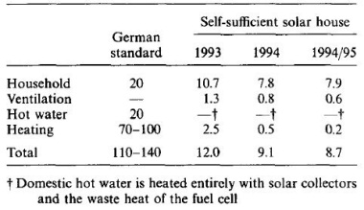

*Table (2): Yearly energy consumption (kWh/m2) for 3 periods compared with current German standard. Energy figures are given related to the living area of 145 m2 and a three-person household* [12].

**3.3.2.4. Carbon footprint after retrofitting:**

* According to Table (2), space heating was almost zero and only necessary in extreme winter periods. Consequently, seasonal storage of low-temperature heat could be avoided. If necessary, back-up heat was supplied via catalytic combustion of stored hydrogen in the central air-supply system of the house. No other heat-distribution system (e.g. radiators) was installed [12].
* Hot water was heated with a bifacially illuminated flat-plate collector [13], back-up was provided by the waste heat of the fuel cell while converting hydrogen and oxygen to electricity.
* In order to meet the remaining energy demand (during periods without sunshine and for cooking), the decision was made for a hydrogen/oxygen energy storage system. This system is essential to the autonomy of the energy supply and it also provides the possibility for seasonal storage of solar generated electricity

**3.3.2.5. Learned lessons:**

From the analysis of "The Self-Sufficient Solar House (SSSH)" we found that:

1. the energy demand of any house could be minimized by combining proven energy-saving technology with highly efficient thermal collectors and PV modules. The need for space heating could be reduced to almost zero
2. The demand for electricity can be significantly reduced by using energy-efficient household appliances
3. a hydrogen/oxygen energy storage system is necessary for energy demand (during periods without sunshine and for cooking)
4. coating the south wall with large area of Transparent Insulation (TI) allows the wall to act as a heat collector during the day and a large radiator during the evening
   * 1. The Barratt Green House Zero Carbon House (UK)



*Figure (13): The Barratt Green House, UK*

Location: the BRE "Innovation Park", Watford, UK.

Year: 2008

Area: nearly 60 m2each floor [14].

**3.3.3.1. Building description:**

* The first home by a mainstream house builder, which meets the requirements to achieve zero carbon emission, designed to Level 6 of the Code for Sustainable Homes.
* is a home that looks to the future with a three-storey, three-bedroom family.
* Constructed from wall with aircrete masonry blocks with thin-joint mortar, concrete floor slabs, Structurally Insulated Panels (SIP) roof and low U-value triple glazing to provide a robust frame with high ‘thermal mass’. This will help reduce any potential overheating problems within the finished house [14].

**3.3.3.2. Carbon footprint before retrofitting:**

1. The heavy concrete floors reduce the need for cooling in the hotter summers. The interior space is flexible, allowing different permutations of layout to suit the changing needs of the occupiers.
2. The house walls are wrapped in 180 mm of insulation to keep heat in and the windows are triple-glazed, allowing a good proportion of glazing equivalent to 25% of floor area. The result is a light and airy home offering a comfortable living environment.
3. High levels of insulation are incorporated in the building’s (envelope), which provides Barratt with a sample of how to achieve Level 6 of the Government’s Code for Sustainable Homes.

**3.3.3.3. Retrofitting elements:**

* The home’s automatic window shutters play a key role here, opening to make the most of daylight or closing to minimize heat build-up from strong sunlight.
* The house intended to achieve air tightness levels. To ensure that the interior has plenty of fresh air without letting cold air in, a special ventilation system with heat recovery replaces the more traditional "trickle vents" seen in recently built homes. Incoming air from the outside is passed through a heat exchanger and warmed by heat captured from outgoing air being extracted from the building then circulated to the rooms [15].

**3.3.3.4. Carbon footprint after retrofitting:**

* The design meets the highest Level 6 of the Government’s Code for Sustainable Homes and will therefore emit no carbon on average over the course of a year. It's the first home by a mainstream house- builder which is so environmentally friendly it would meet the criteria for zero stamp duty.
* Barratt Green House can achieve very low energy bills thanks to:

1. Its high levels of insulations (180mm= 0.11W/m2K).
2. Airtightness (1m3/hr/m2@50pa).
3. Use of PV panels.
4. Rainwater harvesting.
5. Solar shades.
6. Heat recover mechanical ventilation.
7. Highly efficient appliances: Application of triple glazed windows with a low U-value of 0.68W/m2K has also helped to achieve a good glazing to floor area ratio of 25% providing sufficient natural lighting while maintaining low heat-losses through the window [15].

**3.3.3.5. Learned lessons:**

From the analysis of "The Barratt Green House Zero Carbon House (UK)" we found that:

1. High levels of thermal mass in the aerated concrete panel structure, reducing the heating and cooling demand.
2. High performance triple glazing and window shutters which optimize solar gain, control overheating and prevent glare.
3. Mechanical ventilation system with heat recovery by Vortice.
4. A computerised control system ensuring optimal operation of building services and providing a central data storage facility.
5. Solar PV, solar thermal and an air source heat pump.
6. FSC timber used throughout.
7. Sedum roof.
8. Utilizing a rainwater collection and re-use system will supply water for WCs and the washing machine in order to minimize water consumption.

# **Conclusion**

We could summarize the previous five case studies in a comparative analytical table to focus on the mitigations methods used in each case and get the final recommendations:

|  |  |  |  |  |  |
| --- | --- | --- | --- | --- | --- |
|  | (AUC) Egypt | (PTM) Malaysia | Sheffield Eco Terrace (UK) | Self-Sufficient Solar House (Germany) | Barratt Green House (UK) |
| **Energy consumption** | Reduced the consumed energy in:  1) HVAC and domestic hot water.  2) Lighting and other Electrical equipment.  3) Paper consumption. | 1) Passive techniques: (orientation & vegetation) 2)efficient lighting systems, floor slab cooling, double-glazed windows and a thermal wall at its east- and west-facing façades | 1) Used a new type of wall insulation "Spacetherm" 2) Added 50 mm layers of Kingspan insulation to the roof.  3) Added 80 mm of Kingspan insulation to The floor | 1) used energy-efficient household appliances. 2) coated the south wall with large area of Transparent Insulation (TI). | 1) thermal mass in the aerated concrete panel structure. 2) High performance triple glazing and window shutters.  3) Mechanical ventilation system.  4) FSC timber used throughout and Sedum roof. |
| **Energy generating** | Water supply. | Using solar (BIPV) systems does not only provide The electricity needed for the building activities, but also make sells of the surplus to have a payback in a short time. | ------ | Used highly efficient thermal collectors and PV modules. | 1) Solar PV, solar thermal and an air source heat pump. 2) Utilizing a rainwater collection and re-use system |
| **Zero carbon building** | No | Yes | No | Yes | Yes |

*Table (3): A comparative table of all Case studies to indicate whether each building is a zero carbon building or not*

*Source: researcher*

From the above comparative analysis of the selected case studies, we could observe the following:

1. The two main standards of carbon footprint mitigation are governing the energy consumption and using advanced energy generators to offset the consumer credit of energy.
2. The function of the building does not effect on these standards as they depend on energy (consumption / generating). The only responsible factor of the mitigation is building consumption criteria, but governing the residential sector (the vast majority of the city building blocks) will certainly mitigate the carbon footprint of the whole community.
3. It is possible to expect the building carbon performance before the construction-stage and as soon as the design has been finished. Using BIM programs can be applied to predict the sustainability scope of the building before occupation.
4. Some advanced smart technologies solutions can be integrated into the building elements if the carbon emissions were more than predicted.
5. It is impossible to reach the net zero carbon building by applying only one of these two standards. It must be concerned with both energy consumption and energy generating to offset the consumed balance. At the same time not every building that applies the two standards shall be a zero carbon building.

# **Recommendations**

1. Carbon problem should take much more interest in the architectural practice in Egypt as it is expected to cause severe problems globally and locally in the near future. Hence, it is necessary for architects to be concerned with the problem solutions from the early design stage.
2. Architects must focus on the two mitigation standards: energy (consumption & generating) in designing a new building. Even they could not reduce the energy consumption they must apply some smart technologies (PV solar, Wind turbines, water recycling, …. etc) to offset the consumed energy at least.
3. Buildings must also compensate the construction mass area with rooftop farming to rectify the occupied area by the building on the environment.
4. Decision makers should consider using renewable resources as building energy integrated systems that employ both active and passive means. Interesting of applying energy generating systems from renewable resources is the second step, to make the building as self-sufficient unit that do not effect or by effected by the energy shortage, after applying energy consumption passive mitigation methods by sustainability designing the building elements (wall, roof, windows, ….etc) to minimize energy demand or by applying energy consumption active mitigation methods such as the smart integrated ventilation, lighting, and other electrical systems which perform using mechanical systems.
5. It is recommended for future studies to analyze carbon footprint on the urban level at the planning stage of new cities and the exploring the possibility add mitigation elements to the existing city's landscape to pave the way to zero carbon communities.

**References**

1. IPCC, 2011: "Renewable Energy Sources and Climate Change Mitigation" Summary for Policymakers and Technical Summary, special report of the Intergovernmental Panel on Climate Change, A Report of Working Group III of the IPCC, 2011
2. Guan L, 2009: Ling Guan, "Implication of global warming on air-conditioned office buildings in Australia", 2009, Build. Res. Inf. 37 (1), 43–54.
3. Wahidul K, 2014: Wahidul K. Biswas, "Carbon footprint and embodied energy consumption assessment of building construction works in Western Australia", 2014, International Journal of Sustainable Built Environment, Perth, Australia.
4. Fawzy M, 2014: Maha Fawzy Ali, "Applying Smart Lighting Systems in Office Building in Cairo as a Technique for Reducing Carbon Emissions", 2014, Thesis (M.Sc.), Cairo University, Faculty of Engineering. -Department of Architecture
5. Mohamed G, 2015: Gehad Mohamed Naser, "improving energy efficiency in residential buildings to reduce carbon emission", A Thesis Submitted for the degree of Master, Cairo university, 2015
6. Jaskolski T et al, 2015*: Tina Jaskolski, Andrew Petrovich, Richard Tutwiler, Marc Rauch, Wael Taha, Chelsea Estevez and Khaled Tarabieh, "AUC's Carbon Footprint", Research in The American University in Cairo, April 2015*
7. Petrovich A et al, 2012: Andrew Petrovich, Paul Rau, Shaymaa Hassan, FaizaSadek, Tina Jaskolski, Laura Emberson, Richard Tutwiler and Marc Rauch, " Our Carbon Footprint", October 2012, The American University in Cairo.
8. Yoong Y, 2008: Yvonne Yoong, "Pusat Tenaga Malaysia's Zero Energy Office", 2008, Article published in Magazine FuturArc; the voice of green architecture in Asia pacific.
9. Mohammad H, 2015: Haniyeh Mohammad pourkarbasi, "The Eco-Refurbishment of a 19th Century Terraced House", (Energy, Carbon and Cost Performance for Current and Future UK Climates), Thesis submitted to the University of Liverpool for the Degree of Doctor in Philosophy, January 2015, Faculty of Humanities and Social Sciences Department of Architecture.
10. Hui S, 2010: Dr. Sam C. M. Hui, "Zero energy and zero carbon buildings: myths and facts", In Proceedings of the International Conference on Intelligent Systems, Structures and Facilities (ISSF2010): Intelligent Infrastructure and Buildings, 12 January 2010, Kowloon Shangri-la Hotel, Hong Kong, China.
11. Khadka S, 2010: SarojKhadka, "Net Zero Energy buildings", a lecture for 4th year, Civil Enginering, Institute of Technology & Management, Maharajganj.
12. Voss K et al, 1996: K. VOSS, A. GOETZBERGER, G. BOPP, A. HABERLE, A. HEINZEL and H. LEHMBERG, "THE SELF-SUFFICIENT SOLAR HOUSE IN FREIBURG RESULTS OF 3 YEARS OF OPERATION", Fraunhofer Institute for Solar Energy Systems, Oltmannsstr. 5, 79100 Freiburg, Germany, Pergamon, Solar Energy Vol. 58, Nos 1-3, pp. 17-23, 1996
13. Goetzberger et al., 1994: W.Stahl, K.Voss and A.Goetzberger, " The self-sufficient solar house in Freiburg", An article in ScienceDirect Journals & Books, Solar Energy, Volume 52, Issue 1, January 1994, Pages 111-125
14. Barratt Developments PLC, 2015: is Britain's best-known homebuilder, with an approximate 12 per cent share of the UK market. The company has a network of homebuilding divisions strategically located throughout Britain trading under the Barratt Homes, David Wilson Homes and Ward Homes brands, "The Barratt Green House", sponsors: British Homes Awards (PHA), NHBC, National Centre for Excellence in Housing, VELUX, ARUP and Gaunt Francis architects

*www.barrattdevelopments.co.uk*

1. Hashemi A. et al, 2013: ArmanHashemi and KarimHadjri, "Code for Sustainable Homes: opportunities or threats for offsite manufacturing and mass-customization?", 30th October - 1st November 2013, The Visibility of Zero-Energy Housing, ProcsZEMCH 2013 international conference, University of Miami, Miami, USA, 111-122. (ISBN: 978-0-9910608-0-1).